SPL PLANNING V2.0
Project Brief: AI-Augmented Supply Planning and Forecasting System

🚀 Project Vision
To rebuild SPL's current forecasting and inventory planning platform into a modular, AI-augmented, highly scalable system that is easier to maintain, quicker to operate, and significantly faster to onboard new customers. The system should reduce reliance on Power BI for calculations, automate insights and exception handling, and proactively detect and respond to data or process issues.

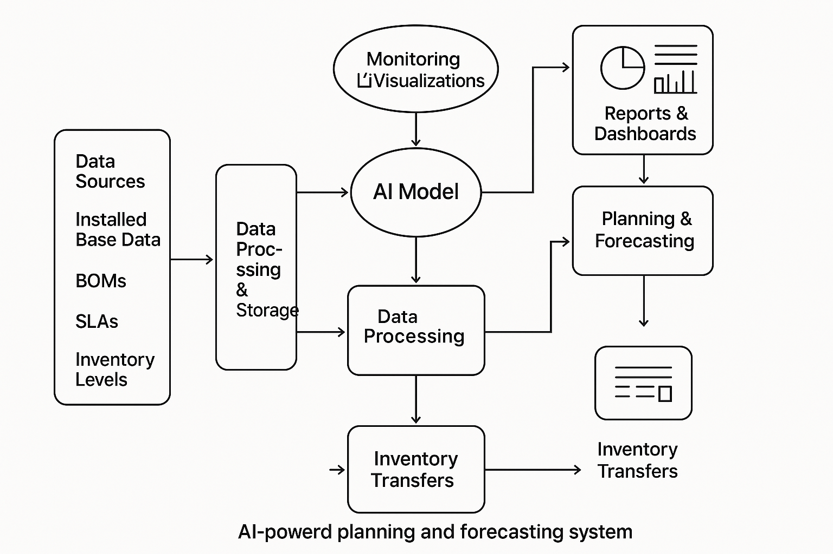

🌐 Overall Architecture Goals
- Modular Design: Decouple the system into services for ingestion, forecasting, SLA analysis, inventory recommendation, reporting, and notification.
- AI-First Engine: Introduce machine learning for usage prediction and GPT-style agents for explainability, insight generation, and exception flagging.
- Schema-Agnostic Customer Onboarding: No more hardcoding to files or columns. Introduce a drag-and-drop or dropdown-based field mapping system per client.
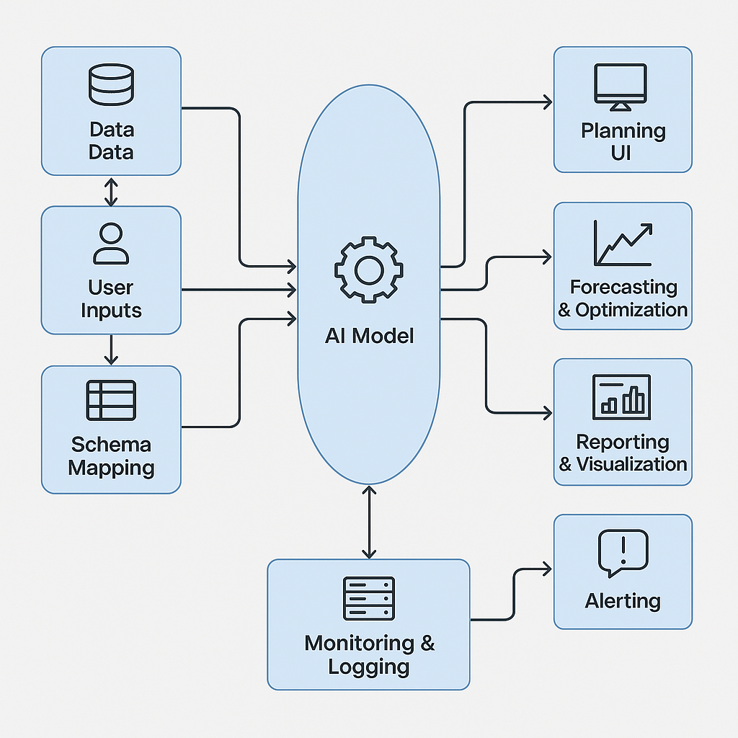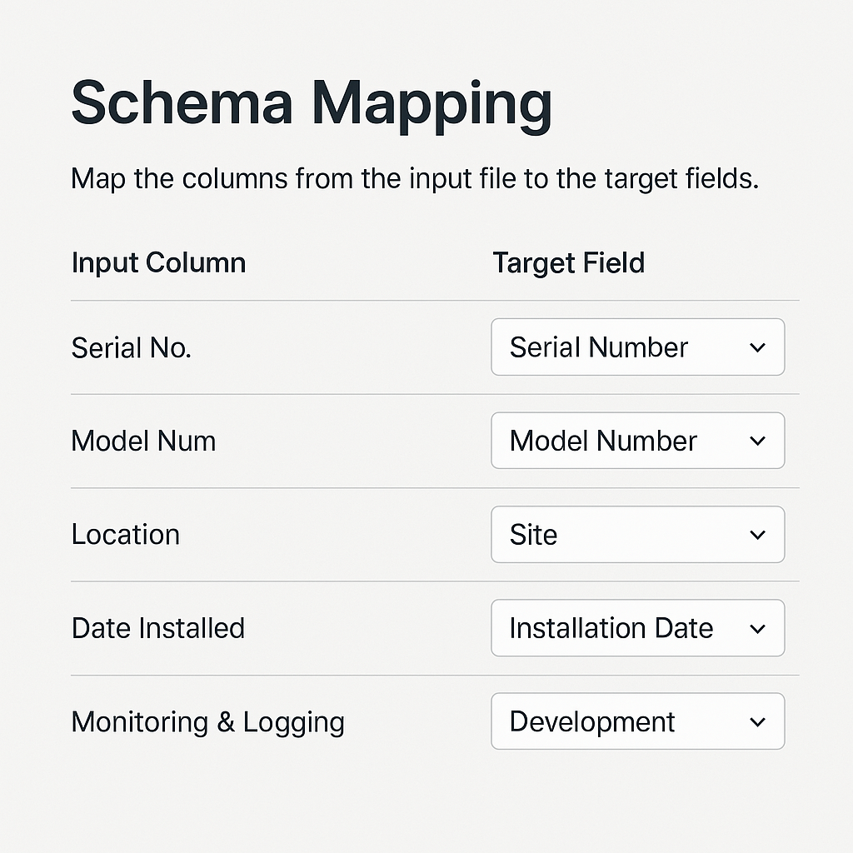
- Live Fault Detection & Resilience: Real-time monitoring of data quality, flow health, and anomalies, with fallback strategies and alerts.
- Workflow-Integrated Output: Daily transfer recommendations and forecasting summaries delivered via SFTP, Teams, and other client-facing interfaces.

📊 Core Modules
1. Data Ingestion Engine
- Accepts files via SFTP or upload
- Validates schema and maps to internal model via onboarding UI
- Logs ingestion results and anomalies
2. Forecast Engine
- Applies rule-based and ML-based logic (e.g. XGBoost, Prophet) to forecast demand per part-location-customer-time unit
- Adjusts for seasonality, trends, usage history, and SLA risk
3. Inventory Recommendation Engine
- Calculates SPL Min (minimum stocking levels)
- Generates daily transfer recommendations
- Responds to constraints: vendor lead times, rework ETA, in-transit stock
4. SLA Risk Analyzer
- Monitors SLA adherence probabilities
- Highlights contracts/sites at risk
- Ties stockout probabilities to financial/SLA penalties
5. Exception & Anomaly Detection
- Detects issues with data inputs, pipeline failures, suspicious forecast deviations
- Generates real-time alerts and fallback suggestions
6. AI Agent (Insight + Action Layer)
- GPT-powered summarizer and data query agent
- Answers questions like:
  - "Why is SSD usage rising in Region A?"
  - "What caused today's drop in approvals for memory modules?"
- Recommends pre-emptive action: expedite POs, adjust forecasts, notify clients
7. Notification and Reporting Layer
- Light dashboarding for visualisation
- Teams/Slack bots for alerting and approvals
- Scheduled or triggered email summaries

🏛️ Tech Stack Recommendations
- Compute: Python (modular services), Azure Functions or AWS Lambda
- Storage: Azure SQL / PostgreSQL
- ML: Scikit-learn, PyCaret, Prophet, optional Azure AutoML
- AI Agent: OpenAI Assistants API, LangChain
- UI: Retool or custom Streamlit / React
- Monitoring: Sentry, Azure Monitor
- Reporting: Lightweight Power BI / Dash / Streamlit

⏳ Execution Plan
Phase 1:
- Break out Power BI logic into standalone services
- Build ingestion engine and onboarding mapper
- Stand up basic forecast engine
Phase 2:
- Add SLA, transfer and approval modules
- Integrate GPT Agent
- Build reporting and workflow tools
Phase 3:
- Health dashboard, notification integration
- Customer onboarding toolkit
- Test scale with multiple clients

🎯 Hackathon Challenge Brief
Challenge Title: AI-First Demand Forecasting Engine & Explainability Layer
The Challenge: Build a working prototype that accepts:
- A historical dataset of part usage (CSV with part number, region, customer, quantity, date)
- SLA target response windows per site
Your system should:
- Forecast next 30-day demand per part-location-customer
- Include a simple GPT-based interface that explains:
  - Why each forecast was generated
  - What influenced the prediction (seasonality, SLA risk, etc)
- Allow users to upload a new dataset and view updated forecasts + explanations
What we’ll look for:
- Model quality
- Explainability UX (use OpenAI or similar)
- Clever or elegant assumptions about real-world constraints (e.g. vendor lead time)
Delivery:
- GitHub link to code
- Short Loom or YouTube demo
- Deployment optional but welcome

🚀 Let's Go
From here, we can develop:
- A clickable mock UI for onboarding or forecasting UX
- System architecture diagram
- Developer backlog with epics/stories for team execution

DETAILED BRIEF
Executive Summary
SPL currently operates a functioning forecasting and inventory planning system using a combination of Power BI, Python, and SharePoint. While this system is delivering value, it is becoming unmanageable due to performance bottlenecks, hardcoded configurations, and scaling complexity across multiple customers.
The goal is to rebuild this system into a modular, AI-first, scalable forecasting platform that simplifies onboarding, automates insights, detects errors in real time, and makes proactive, intelligent decisions about stocking and transfers based on live and historical data.
This document outlines the full end-to-end requirements, architecture, features, functional expectations, and design considerations for development.

🌐 Platform Goals
- Modular: Calculations, reporting, forecasting, notifications, and onboarding are all logically separated
- AI-Augmented: Forecasting logic and explanations enhanced via ML and LLMs
- Resilient: System self-detects and self-reports failures, omissions, or risks in real time
- Client-Ready: Easy to onboard new clients, support custom logic, and generate daily transfer recommendations
- Multi-Tenant: System supports multiple clients with secure data separation
- Cost-Controlled: Built with efficient cloud-native components, avoiding unnecessary compute cycles

✅ Core Capabilities
1. Customer Onboarding & Schema Mapping
- Drag-and-drop or dropdown mapping of input file columns to expected fields
- Supports file types: .csv, .xlsx, .xlsm, .json
- Handles schema changes and unexpected column names using AI-assisted suggestions
- Ability to save, validate, and reuse schema templates per customer
- Validate formats and warn on unusual values (e.g. "Model Number" column has 87% numeric values, 13% alphanumeric)
2. Data Ingestion Layer
- Accepts scheduled uploads or polls secure SFTP folders for new files
- Stores raw and validated datasets into structured warehouse (PostgreSQL or Azure SQL)
- Tracks ingestion status and health (e.g. timestamp, file integrity, schema match)
- Sends alerts for ingestion failures, delays, or corrupt formats
3. Forecasting Engine
- Core logic:
  - Forecast future part usage per part-location-customer-time period
  - Incorporate usage history, BOM depth, failure rates, SLA type, environmental factors
  - Adjust for trends, seasonality, and growth per client or model
- ML Models:
  - Begin with Prophet and XGBoost, later allow per-customer tuning or AutoML
  - Forecast window configurable (default: 30 days)
- GPT/LLM Explanation Layer:
  - Auto-summarise key changes and top drivers for forecast
  - Offer natural language insight via web UI and dashboards
4. SLA Risk Assessment
- Evaluate SLA compliance risk based on:
  - Usage velocity
  - Lead times
  - Current stock vs minimum required stock (SPL Min)
  - Historical SLA breaches
- Generate alerts and suggest preventative actions:
  - Expedite PO
  - Flag region for monitoring
  - Recommend stocking at fallback location
5. Inventory Recommendation Logic
- Define "SPL Min" = minimum stocking level per part-location pair
- Determine:
  - Current stock
  - Rework stock + ETA
  - In-transit inventory
  - Open POs + ETA
- Calculate shortages vs SPL Min
- Recommend:
  - Transfer from overstocked location
  - Raise PO
  - Expedite part
- Include clear reasons: "Current stock = 2, SPL Min = 5, 30-day usage avg = 6, rework ETA > 7 days"
6. User Approval Workflow
- UI for clients to approve, reject, or comment on recommendations
- Daily workflow:
  - View recommended transfers
  - Accept/reject by line
  - Filter by region, category, urgency
- Store decisions and reasoning for audit and retraining ML models
- Output approved transfers to SFTP or client API
7. Monitoring & Exception Handling
- System watches for:
  - Missing files
  - Bad schemas
  - Forecast run failures
  - Null output data
- Includes retry, fallback (last known forecast), and user alert mechanisms
- Alert types:
  - Email
  - Teams bot
  - Slack webhook
- Common errors flagged:
  - Empty file
  - Unexpected symbols in override columns
  - Schema drift
8. AI Agent & Insights Layer
- GPT-style assistant embedded in dashboard
- Can respond to:
  - "Why are SSD transfers high this week?"
  - "What changed in site X’s usage?"
  - "What’s our highest-risk site today?"
- Explains trends, auto-summarises week/month data changes
- Suggests new reports, visual filters, approval patterns
9. Edge Case Handling
- If a site closes and assets move to a new location:
  - Forecast logic must merge usage from historical and new site
  - Site transfer recorded in metadata (e.g. OldSiteCode -> NewSiteCode)
  - Forecasting should carry usage trends across transitions
10. Reporting & Dashboard Layer
- Web-based dashboards with role-based views:
  - Forecasts
  - SLA risk
  - Part movement
  - Approvals
  - Exceptions
- AI-generated commentary on each panel
- Reports exportable to Excel and PDF
- Optional Power BI compatibility for legacy clients

📊 Technical Stack (Recommended)
- Backend: Python, FastAPI or Flask
- Storage: PostgreSQL or Azure SQL
- Forecasting: Prophet, XGBoost, PyCaret, optional Azure AutoML
- AI Agent: OpenAI Assistants API, LangChain
- UI: Streamlit for internal apps, React + Tailwind for production dashboard
- Automation: Power Automate, Celery, or AWS Step Functions
- Monitoring: Sentry, Datafold, Airbyte logs
- Notifications: Email, Teams Bot, Slack
- Export: Excel (xlsxwriter or Pandas), PDF (ReportLab or PDFKit)

🏃️ Daily Workflow Example
- Client sends inventory + install base file overnight
- System ingests file at 4:00 AM, validates schema via saved config
- Forecasting engine runs with AI layer generating usage prediction + commentary
- SLA module flags top 5 sites at risk of breach
- Inventory engine proposes 18 transfer recommendations
- Dashboard loads by 8:30 AM with full forecast, AI commentary, and pending approvals
- Customer approves/rejects via UI by 9:30 AM
- Output pushed to SFTP
- Summary emailed to SPL manager and logged

🎯 Hackathon Challenge Brief
Challenge Title: AI-First Demand Forecasting Engine & Explainability Layer
The Challenge: Build a working prototype that accepts:
- A historical dataset of part usage (CSV with part number, region, customer, quantity, date)
- SLA target response windows per site
Your system should:
- Forecast next 30-day demand per part-location-customer
- Include a simple GPT-based interface that explains:
  - Why each forecast was generated
  - What influenced the prediction (seasonality, SLA risk, etc)
- Allow users to upload a new dataset and view updated forecasts + explanations
What we’ll look for:
- Model quality
- Explainability UX (use OpenAI or similar)
- Clever or elegant assumptions about real-world constraints (e.g. vendor lead time)
Delivery:
- GitHub link to code
- Short Loom or YouTube demo
- Deployment optional but welcome
Developer Backlog

EPIC 1: Ingestion & Schema Mapping
Allow ingestion of structured files via SFTP/upload, mapped to standard internal schema per customer.
US-101: Upload/Receive Files Securely
- As a data admin
- I want to upload or receive files via SFTP or drag-and-drop
- So that customer data can be ingested automatically
- Acceptance Criteria:
  - Support .csv, .xlsx, .xlsm, .json
  - Save ingestion logs with timestamp and source
US-102: Schema Field Mapper (UI)
- As a customer onboarding user
- I want to map incoming file columns to expected fields using a UI
- So that we don't have to hardcode ingestion logic
- Acceptance Criteria:
  - Dropdown or AI-suggested field matches
  - Save mappings per customer
  - Validate for required fields and datatypes
US-103: Schema Drift Alerts
- As a system
- I want to detect unexpected changes in column names or missing fields
- So that ingestion does not silently fail
- Acceptance Criteria:
  - Notify via email/Teams
  - Flag file for manual inspection
Tags: ingestion, onboarding, schema

EPIC 2: Forecast Engine
US-201: Generate Forecast per Part-Location-Customer
- As a demand planner
- I want to see 30-day usage forecasts
- So that I can stock proactively
- Acceptance Criteria:
  - Forecast based on usage, trends, seasonality, SLA
  - Output confidence intervals
US-202: GPT Insight Layer for Forecast
- As a planner
- I want an AI-generated explanation of forecast changes
- So that I understand what changed
- Acceptance Criteria:
  - LLM outputs one paragraph per location
  - Include references to data ranges (e.g. usage spike, drop in failure rate)
Tags: forecasting, AI, ML, explainability

EPIC 3: SLA & Risk Engine
US-301: SLA Risk Scoring
- As a service lead
- I want to be notified when a site is likely to breach SLA
- So that I can act before service failure
- Acceptance Criteria:
  - Score based on lead time, stock vs demand, historical breach
  - Output top 5 risky sites daily
Tags: sla, risk, alerting

EPIC 4: Inventory Transfer Recommender
US-401: SPL Min Calculation
- As a system
- I want to calculate the minimum stock level per part-location
- So that recommendations are aligned to demand and SLA
- Acceptance Criteria:
  - Dynamic formula: (average daily usage × lead time) + SLA buffer
  - Modifiable via admin panel
US-402: Transfer Recommendation Generator
- As a planner
- I want to see proposed transfers from overstocked to understocked sites
- So that I reduce procurement and SLA risk
- Acceptance Criteria:
  - Justify each transfer line item
  - Group by urgency
Tags: inventory, supplychain, rebalancing

EPIC 5: User Approval Workflow
US-501: Approval Interface
- As a client manager
- I want to approve/reject transfers via a UI
- So that I retain control over stock movement
- Acceptance Criteria:
  - Accept/reject per line
  - Comment per item
  - Filter by region, part type
US-502: Rejected Logic Reflow
- As a system
- I want to flag rejected items for secondary logic
- So that planners can adjust recommendations
- Acceptance Criteria:
  - Store reasons
  - Reflow logic on rejection events
Tags: approval, ux, workflow

EPIC 6: Exception Monitoring & Alerts
US-601: Missing File/Flow Halt Detection
- As a system
- I want to notify stakeholders when key processes don’t complete
- So that human intervention is possible before delivery cut-off
- Acceptance Criteria:
  - Missed file delivery alert
  - ETL stage timeout detection
  - AI failure fallback logic
Tags: monitoring, alerting, recovery

EPIC 7: Reporting & Export Layer
US-701: Dynamic Reporting Dashboard
- As a manager
- I want to view live dashboards for forecasts, risks, and approvals
- So that I can assess system and team performance
- Acceptance Criteria:
  - Filter by date, customer, site, SKU
  - AI-generated commentary included
US-702: Export to Excel/PDF
- As a customer
- I want to export reports in familiar formats
- So that I can share internally
- Acceptance Criteria:
  - Button to export any dashboard view
  - Include applied filters and date stamps
GITHUB SCAFFOLDING
📁 ai-forecasting-platform/
├── 📁 backend/
│ ├── ingestion/
│ ├── forecasting/
│ ├── sla_analysis/
│ └── transfer_logic/
├── 📁 frontend/
│ ├── onboarding-ui/
│ └── dashboard/
├── 📁 data/
│ └── sample_client_files/
├── 📁 alerts/
├── README.md
├── .gitignore
├── requirements.txt
└── project.yml (for issue templates / roadmap)

